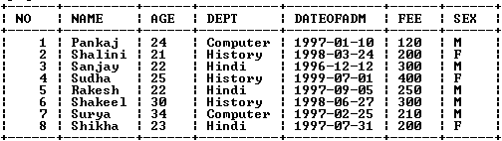**Table: STUDENT**

**QUERIES:**

1. To show all information about the students of history dept.
2. To list the names of female students who are in the Hindi department.
3. To list the names of all the students with their date of admission in ascending order.
4. To display students name , fee , age for male students only.
5. To count the number of students with age<23.
6. To insert a new row in the student table with the following data:

9,”Zaheer”,36,”computer”,12/03/95,230,”M”

